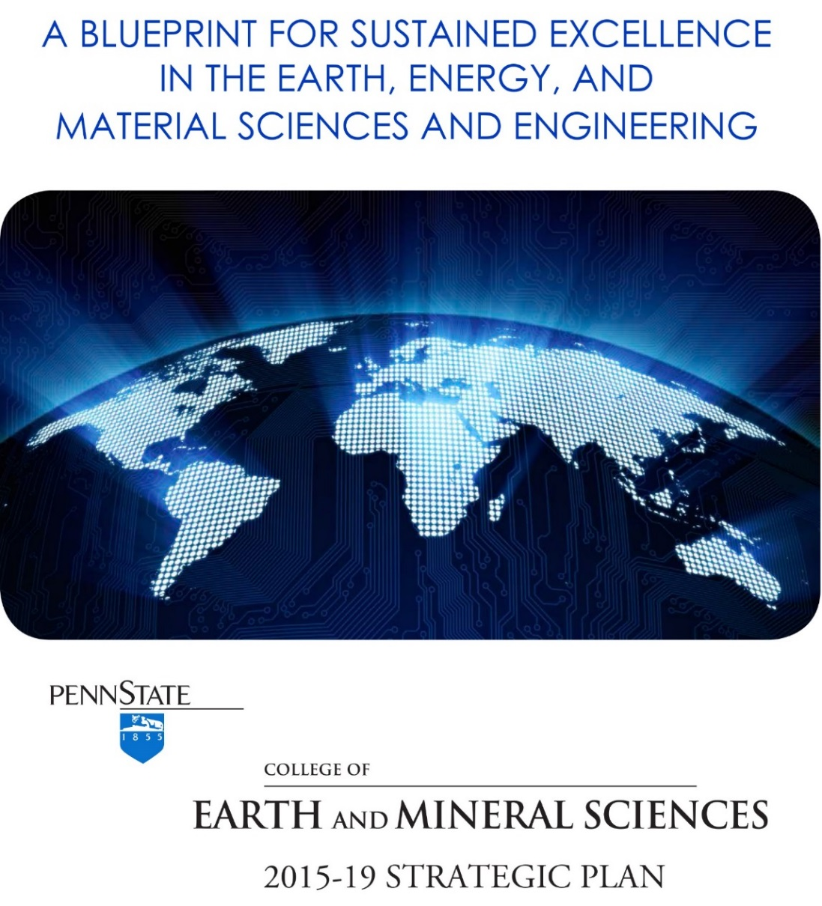

INTRODUCTION – THE WAY FORWARD
The first full decade of the twenty-first century is behind us. As we near the middle of the second decade, many of the top scientific challenges in the earth, energy, and materials sciences and engineering that were confronted at the close of the twentieth century are even more urgent today. Securing affordable and sustainable energy for the world, understanding and responding to anthropogenic climate change, and developing highly functional new materials remain among the highest scientific priorities for improving the quality of life for our citizens. New challenges have come into sharp focus for the faculty and students in the College of Earth and Mineral Sciences (EMS), such as ensuring adequate supplies of high-quality fresh water to meet an ever-growing set of demands; learning how to process, store, and analyze huge volumes of earth, energy, and materials data and information; improving the scientifically sound management of geophysical hazards and risk; and using advanced theoretical spectroscopy techniques to investigate dynamic properties of materials.
Such challenges will call for innovative ways of training students to give them the skills to think critically and to exercise a strong moral compass. Students should be able to work in problem-solving teams, communicate clearly, and function effectively in an international setting—and they should be encouraged to dream of and implement innovative solutions to difficult problems. The challenges will also call for new, fundamental discoveries that are only possible when talented faculty and students are given the resources and encouragement to tackle daunting questions using novel, often interdisciplinary, scientific approaches and the very best research infrastructure in the world. Students must also become facile with successfully completing substantive academic courses online. Online education extends a tool for lifelong learning to students.
The college is poised to seize the momentum generated by a five-year-long commitment to building up expertise in the energy sciences and engineering (see Preparing the Next Generation of Earth, Energy and Materials Scientists and Engineers, EMS Strategic Plan for 2010-14) leveraged by its long-standing strength in the earth and materials science. The strategic plan proposed in this document is a roadmap designed to complete the journey toward balancing the college’s strengths in the earth, energy, and materials sciences and engineering.

Our Strengths
EMS, with its five departments and three institutes, is among the elite colleges in its fields. The five departments include the John and Willie Leone Family Department of Energy and Mineral Engineering, the Department of Geography, the Department of Geosciences, the Department of Materials Science and Engineering, and the Department of Meteorology. The three EMS institutes include the John A. Dutton e-Education Institute, the Earth and Environmental Systems Institute (EESI), and the EMS Energy Institute. EMS also has a close partnership with the Materials Research Institute (MRI). MRI provides leadership both at Penn State and in the materials community worldwide, coordinating materials-related activities, maintaining core and shared facilities, training students, and fostering collegial exchanges of expertise.
According to recent national rankings, U.S. News and World Report ranked the college’s geology program first, geochemistry program second, petroleum and natural gas engineering program fifth, materials science and engineering fourteenth, and the National Research Council ranked meteorology and geography among the top ten programs in the nation. In the most recent institutional rankings released by the National Science Foundation of total research expenditures for science and engineering, many of the college’s programs were ranked in the top ten: materials (first), total engineering (fifth), atmospheric sciences (ninth), and earth sciences (ninth).
EMS has had a long tradition of innovation and leadership in its disciplines. Over the past thirty years, EMS established the first major initiative in the earth system sciences with the establishment of an interdisciplinary institute that has evolved into EESI. The EMS Energy Institute was established by a special state appropriation from the Pennsylvania legislature and has been a highly recognized focus for applied and fundamental research in the energy sciences and engineering. EMS led Penn State to be the first university to acquire supercomputing capabilities for climate system modeling with the purchase of a Cray XMP computer in the early 1990s. More recently, EMS joined forces with the College of Engineering to form the Institute for Natural Gas Research (INGaR), which will bring twelve new faculty members in various technical areas of natural gas discovery, extraction, conversion, transport, and consumption of shale gas. These positions and other faculty and staff positions that open up over the next five years will provide opportunities for EMS to enhance the diversity of our workforce. We will continue to work closely with the Office of Affirmative Action and the Office of Human Resources to ensure that we recruit and retain a diverse EMS workforce. The leadership and management within the college has been diversified with leadership positions currently held or held during the past five years by several female and minority faculty members leadership positions during the past five years, including our college’s first female department head.. The thinking and planning reported in this document is an extension of the bold but calculated eagerness of EMS faculty, staff, and students to keep EMS in a leadership position atop the earth, energy, and material sciences and engineering.

Strategic Planning Process
For more than a century, EMS has been a beacon of intellectual leadership on issues of utmost importance to the welfare of the Commonwealth and the nation. In the college’s previous strategic plan, the strengthening of its energy science and engineering assets was given considerable attention. Significant progress was achieved. The 2015-19 plan builds upon the successes of the previous plan by bringing together two of the most important limiting resources to our economic and environmental goals: the interactions of water quality and availability, and energy security. Many of our strategic goals, whether in research, teaching, or service and outreach, are interrelated with those fundamental energy and water interactions.
The EMS faculty began a college-wide discussion of the essential elements of a new five-year strategic plan during the summer of 2012. Over the ensuing two years, individual departments and institutes worked internally and in coordination with the EMS Office of the Dean to develop challenging and both internally and externally consistent unit-level strategic plans. During the past year, the emerging unit plans guided the 2015-19 strategic plan presented herein. Two major cross-college workshops involving associate deans, department heads, and institute directors were conducted by the Office of the Dean to review early drafts of the college plan. To coordinate organizational change to support diversity, input was provided at all steps in the process by the EMS Diversity Council, working in coordination with the Office of the Associate Dean for Educational Equity (ADEE).
The plan is organized to begin with a synopsis of our mission, vision, goals, alignment of our goals with the University’s overall leadership plans, the college’s commitment to integrity and ethical behavior, and our response to the University’s Core Council recommendations. That synopsis is supported by a set of foundational documents contained in the plan’s appendices that provide the underlying rationale and implementation for each of the college’s stated goals.

MISSION
To develop new discoveries about how the earth’s systems interact with one another and with people and their institutions and to use the knowledge gained from those discoveries to inspire students to become new generations of leaders.

VISION
EMS is a recognized leader in all of its disciplines. Not only is it known for ground-breaking research and high-quality teaching, but, increasingly, as an adviser to industry and government on important but still contentious matters like climate change and energy security. To that end, the college proposes a bold new vision that recognizes its role as a leading source of discovery, pedagogy, and sound advice:
The College of Earth and Mineral Sciences is where the field manual for the earth and its resources is created by pioneers and learned by new generations of leaders.

GOALS FOR 2015-19 STRATEGIC PLAN
Our successes in meeting the goals set in our 2010-14 strategic plan provide us the momentum to take on a new set of challenges over the next five years. Building on our progress, this strategic plan focuses on six fundamental goals that will continue to further develop the strength and quality of our college. In this section, the strategic mission of each goal is described along with the key initiatives and strategies that will help the college realize each goal. Also included are the key performance indicators that will be used to measure and evaluate the effectiveness of our strategies.

Goal 1: Build on the college’s reputation for scientific leadership in the earth, energy, and materials sciences and engineering
Strategic Mission: Extending new strengths gained from previous investments in energy science and engineering to develop the nexus of energy and water science and water resources while reinforcing core strengths in the earth, energy, and materials sciences.

Goal 1 - Initiative 1: Address scientific and societal challenges through research
Strategies | Key Performance Indicators
- Establish a water initiative targeting the nexus of energy and water  - Leverage the newly established INGaR to build a research and graduate training powerhouse in the discovery, extraction, processing/conversion, transport, and use of unconventional natural gas  - Initiate a new program focusing on large data assimilation pertaining to forecasting in the earth, energy, and materials sciences  - Develop capabilities to understand and model decision making under uncertainty and risk in the earth and energy sciences  - Launch a new thrust in critical materials by design by applying additive manufacturing science to structural biomaterials (bone, cartilage, ligaments, etc.); developing components for energy systems and water treatment (filters, membranes, catalytic supports); and designing advanced materials for sensors, actuators, and electronic devices | - Global Water Center created  - Semi-annual reviews of proposals submitted, projects awarded, and research expenditures to assess the relative health of our proposal support and research enterprise  - Rankings of our departments relative to our peers by the National Research Council and other entities  - Number of prestigious awards, society fellows, and academy memberships  - Citations pertaining to new strategic priorities by EMS faculty in prestigious disciplinary and interdisciplinary journals

Goal 1 - Initiative 2: Build new faculty strength and capacity
Strategies | Key Performance Indicators
- Fine-tune the composition of our faculty to enhance existing strengths and build new capacity and expertise  - Fill faculty positions allotted to the college from the Institute for CyberScience, INGaR, and the Rock Ethics Institute  - Renew faculty coverage lost to attrition to complement existing strengths | - Success at filling the faculty positions already allocated to INGaR, Institute for CyberScience, and Rock Ethics Institute  - Assess needs for faculty with specific expertise and the success in attracting the very best candidates to fill those positions on a three-year interval

Goal 1 - Initiative 3: Create a culture of innovation and deployment of our scholarship
Strategies | Key Performance Indicators
- Better inform our faculty and students about the resources available to deploy their scholarship to benefit society and to assist them when possible  - Enhance patent and licensing awareness through a series of workshops conducted in collaboration with the Office for Research Protections and the Office of Technology Management  - Create the Earth and Mineral Sciences Innovations for Sustainability (EMSIS) program to provide financial support in the form of seed funding to enable researchers (faculty and students) to realize the commercial potential of their intellectual property for the betterment of society  - Cultivate awareness among our students about the importance of protecting and deploying IP. This will be accomplished via presentations during first-year seminars, undergraduate engineering design classes, and our graduate-level first-year professional development seminar series | - Track patent disclosures, provisional patents, patent applications, licenses, and royalty revenue generated by IP created by our faculty  - Number of startup companies formed — evaluated on an annual basis  - Evaluate the effectiveness of EMSIS seed funding program in spinning out technology to the marketplace. Program will have a five-year sunset provision to allow for an evaluation of its relative success in achieving its goals.

Goal 1 - Initiative 4: Expand graduate education beyond residential instruction to a global audience
Strategies | Key Performance Indicators
- Launch four master of professional studies degree programs  - Increase commitment to our existing Fellows Incentive Program to boost the number of National Science Foundation (NSF) Graduate Research Fellowship–caliber recruits  - Coordinate allocation of our graduate assistantships with Educational Equity to promote diversity while maintaining cost share capacity  - Create a college-wide course that addresses professional ethics, scholarship and research integrity, conflict of interest management, scientific methodology, sustainability, safety, IP, writing and communications, career path planning, and professional development opportunities and resources  - Expand graduate program support to a full-time position within the Office of the Associate Dean for Graduate Education and Research (ADGER) | - Assess enrollments, student credit hours, and revenue generated by our participation in World Campus and from summer student credit hours  - Track progress in attracting underrepresented minority students and identifying and appointing Bunton-Waller Fellows  - Increase enrollment of NSF Graduate Research Fellows  - Students’ success in being awarded University Graduate Fellowships, Distinguished Graduate Fellowships, and other similar awards

Goal 1 - Initiative 5: Research infrastructure and support for performing cutting-edge research
Strategies | Key Performance Indicators
- Coordinate placement of new, high-cost analytical instruments in core facilities, jointly funded with other colleges, institutes, and central administration  - Assist in establishing approved fee schedules for the Penn State User Research Facilities in order to promote the broadest usage and maintenance of specialized instruments and capabilities in the college  - Create staff training programs for electronic proposal internal approval form (e-PIAF), protection/assignment of IP, foreign access control, technology control plans, cost share guidelines, pre- and post-award processes, terms and conditions, conflict of interest/commitment management, non-disclosure and memoranda of understanding agreements, critical incident planning, continuity planning and safety management  - Implement compliance management through a compliance specialist housed in ADGER  - Realign research portfolio to projects with full F&A recovery, while respecting the land grant mission of the University  - Complete Steidle Building renovation and reoccupation; commence Hosler Building redesign and renovation planning; complete Deike Building renovations to permit Hosler renovations  - Rebuild capacity and enhance efficiency of EMS machine shop | - Compliance performance on Technology Control Plans (TCP), Conflict Of Interest System (COINS) disclosures, e-PIAFs, safety and critical incident issues  - Participation in training workshops  - User facilities revenues/expenditures  - College cost share/equipment overall cost per year on new inter-unit equipment purchases placed in core facilities  - Success rate in equipment grant proposals  - Machine shop revenues/expenditures and subsidy rate

Goal 2: Provide seamless access for all EMS students to an EMS education that is driven by learner needs, regardless of location or situation – become One College, Geographically Distributed
Strategic Mission: Giving our students at University Park (UP) and across the Penn State campuses and Penn State World Campus the opportunities to learn how to live productively in a globalized world, to become lifelong learners, and to attain the practical proficiencies that come by engaging students in real-world experiences in their chosen majors.
Strategies | Key Performance Indicators
- Provide seamless access for all EMS undergraduate students to the entire breadth of the college’s learning by integrating online and resident education courses into a package that provides maximum flexibility and opportunity for EMS students located anywhere within the Penn State system — enabling them to progress toward their degrees in a timely manner regardless of where they begin their studies  - Enhance EMS’s welcoming campus climate by increasing the visibility of our Office of the ADEE by relocating the Office of the ADEE to the expanded Ryan Family Center  - Increase the number of engaged scholarship and leadership opportunities through the creation of the EMS Office of Engaged Scholarship (EMSOES) in order to prepare all EMS students to graduate as informed, engaged, globally knowledgeable citizens  - Identify potential underrepresented EMSAGE Laureate candidates and work regularly with them to establish being a Laureate as one of their academic goals, Develop the plan for achieving this recognition and guide them throughout their time at Penn State to ensure that they participate in a curriculum that fosters global cultural competencies  - Create state-of-the-art digital learning, advising, and studying spaces throughout the college that enable all EMS students to grow professionally throughout their entire studies regardless of location | - Use of EMS advising and tutoring services by UP, non-UP resident campus, and World Campus students  - Assess whether the time to degree is improved with increased online course offerings including comparison of students starting at UP and at locations other than UP  - Student outcome assessments  - Determine if EMSOES helps grow the number of students attaining EMSAGE laureate status  - Number of underrepresented EMSAGE laureates  - Number of EMS students by campus, including World Campus, who participate in engaged scholarship activities  - Track the total number of EMS pre-major and major students across the campuses as well as the number of students at each campus to gauge the percentage of students using the expanded facilities

Goal 3: Invest in recruiting and retaining talented diverse students into EMS graduate programs and facilitate their career development
Strategic Mission: To build a pipeline of excellent minority students into EMS graduate programs and to provide those students with the mentoring and tools to succeed during their time in EMS and beyond.
Strategies | Key Performance Indicators
- Co-develop and co-teach online topic courses with minority-serving institutions  - Develop a ‘home-grown’ pool of diverse talent through EMS inclusion into the Penn State Millennium Scholars Program  - Use the EMS Summer Institute to coordinate summer efforts of our current summer programs directed at undergraduates  - Take a leadership role in the new Penn State STEM Fall Open House and work toward increasing the effective dissemination of information about this program to our target audience of potential minority graduate students in the earth and mineral sciences  - Develop a Pre-doctoral Academy to serve as an intensive orientation for incoming minority students  - Provide EMS minority graduate students with enhanced mentoring and structured professional development needed to succeed during their time in EMS and beyond, including a Bridge to Ph.D. program  - Secure funding to provide selected minority students the opportunity to enhance their graduate experience through student-controlled funds to be used for professional travel, research, equipment, books, and many other needs during their doctoral studies | - Number of co-taught online EMS topic courses, number of partner minority-serving institutions, number and demographics of students enrolled in those courses  - Number of underrepresented minority graduate student applications, offers, and accepts  - Number of Bridge to Ph.D. minority students accepted into Research I earth and mineral sciences Ph.D. programs  - Number of graduate degrees conferred on underrepresented students, time to degree completion, tracking of initial job placement, and ongoing tracking of career path  - Student and adviser feedback to assess and shape the ongoing development of each program

Goal 4: Continue to develop alternative revenue streams that help sustain the college’s excellence, especially in the area of philanthropic fundraising
Strategic Mission: To engage the college’s best donor prospects to become proactively involved in the development of key strategic initiatives included in this five-year plan with the goal of cultivating transformative gifts that help provide the resources necessary for those priorities to be met, especially in the areas of faculty development.
Strategies | Key Performance Indicators
- Launch and administer a new University-level fundraising initiative for the college  - Identify opportunities and raise funds for targeted areas and programs  - Accumulate resources needed to recruit and retain the very best faculty in their fields and enable them to perform at the highest levels in teaching and research  - Institute named and endowed professorships  - Establish proof-of-concept funds to support high-risk but potentially transformative research ideas  - Create highly competitive graduate fellowships, especially those supporting underrepresented populations  - Shepherd corporate and private donations to support the construction of active-learning classrooms and laboratories throughout the college | - Creation of endowed Dean’s Chair  - Number of endowed and named professorships  - Number of new graduate fellowships established  - Amount of funding to support active-learning classrooms — including support for staffing, maintenance, and ongoing technological advancements in each facility  - Amount of private support raised to fund high-risk, highly innovative ideas

Goal 5: Build our digital future through improvements in information technology (IT) and provide an innovative, state-of-the-art research and teaching infrastructure that empowers and supports our students and faculty
Strategic Mission: EMS will continue to engage the University to see key infrastructure improvements through to completion and to work closely with the University’s Information Technology Service to transition cost-saving and service-enhancing improvements that are possible with the new Data Center initiative.
Strategies | Key Performance Indicators
- Create a Big Data infrastructure that will provide a large-scale, shared storage system and accompanying data backup  - Increase investment in high-performance computing (HPC) capacity  - Improve our education infrastructure to support online education  - Develop technology, techniques, and training to enable and support active-learning classrooms  - Provide advanced IT services in support of teaching and research | - Big Data usage statistics of the storage and HPC systems – number of users, terabytes stored, CPU time consumed  - Number of proposals and awards that cite storage system and HPC capabilities  - Evaluate the improvements in the online education infrastructure  - Number of new funding streams developed to support the online education infrastructure  - Development of active classroom technology with improved ease of use  - New active learning spaces deployed in energy and mineral engineering, geography, and materials science and engineering  - Elimination of duplicate services provided by IT staff  - Data management specialist and a computation support specialist employed by college  - Dedicated research support IT group formed to engage researchers and deeply understand IT needs

Goal 6: Incorporate sustainability thinking into all aspects of EMS
Strategic Mission: EMS is committed to promoting principles of sustainability in its research, teaching and in practical applications.
Strategies | Key Performance Indicators
- Infuse sustainability literacy into student learning  - Conceptualize sustainability through emphasis on a Life Cycle Analysis (LCA) approach to the use of critical natural resources such as energy and water  - Guide the world to a sustainable energy path  - Communicate sustainability to the public through development of a strong science communications capability that enables effective conversion of highly technical scientific information into easy-to-understand public knowledge about how the earth’s systems work  - Foster interaction and coordination of efforts among EMS’ three Green Teams for better communication and implementation of sustainability practices  - Increase the number of EMS Green Teams  - Participate in programs created by Penn State’s Finance and Business Office that promote sustainability best practices | - Number of EMS courses that incorporate sustainability topics  - Strengthen ties with the Sustainability Institute to work toward Penn State’s vision of sustainability  - Continue participation in Penn State’s Bulk Buy program, which was established to minimize costs and maximize efficiencies for purchasing equipment  - Reduce power consumption of computers and podiums in labs and classrooms through ongoing participation in the Office of Physical Plant’s BigFix program

ALIGNMENT OF EMS GOALS WITH THE UNIVERSITY’S OVERALL LEADERSHIP PLANS
 | Goal 1:  Build on the college's reputation for scientific leadership in the earth, energy, and materials sciences and engineering | Goal 2:  Provide seamless access for all EMS students to an EMS education that is driven by learner needs, regardless of location or situation - become One College, Geographically Distributed | Goal 3:  Invest in recruiting talented minority students into EMS graduate programs and facilitate their career development | Goal 4:  Continue to develop alternative revenue streams that help sustain the college’s excellence, especially in the area of philanthropic fundraising | Goal 5:  Build our digital future through improvements in information technology (IT) and provide an innovative, state-of-the-art research and teaching infrastructure that empowers and supports our students and faculty | Goal 6:  Incorporate sustainability thinking into all aspects of EMS
Themes/Supporting Strategies:
Enhancing Our Health and Well-Being |  |  |  |  |  | X
Managing and Stewarding Our Resources | X | X | X | X | X | X
Transforming Education and Access | X | X | X | X | X
Leveraging Our Digital Access |  | X | X |  | X
Exploring and Promoting Our Cultures |  | X | X |  |  | X
Academic Infrastructure and Support |  | X | X | X | X
Outreach and Engagement | X | X |  |  |  | X
Business Processes | X |  |  | X | X
President Barron's Six Initiatives:
Excellence | X | X | X | X | X | X
Student Engagement |  | X | X |  |  | X
Economic Development and Student Career Success |  | X | X
Diversity and Demographics |  | X | X
Access and Affordability | X | X | X | X
Technology and Curriculum Delivery | X | X | X |  | X | X
Major Penn State Initiatives:
Sustainability | X | X |  |  |  | X
Global Engagement | X | X | X

INTEGRITY AND ETHICAL BEHAVIOR
EMS is highly committed to a stringent standard of inclusiveness, integrity and ethical behavior in all educational, research, and outreach programs. Embedded in our strategic plan is the philosophy that all faculty, staff, and students embrace this stringent standard and that this will help us chart the path forward as not only one of the world’s most respected colleges in the earth, energy, and materials sciences and engineering, but also one that is known to ascribe to the highest inclusive, integrity and ethical ideals.
The University defines academic integrity as the pursuit of scholarly activity in an open, honest, and responsible manner, and academic integrity is a basic guiding principle for all academic activity in the college. EMS instructors regularly communicate academic integrity policies to students. Integrity and high ethical behavior related to research and other scholarly activities is expected of all faculty and students. The college website for current undergraduate and graduate students provides information and resources on academic integrity and ethics. EMS also partners with the Office for Research Protections to ensure that all EMS research is conducted in accordance with federal, state, and local regulations and guidelines that protect human participants, animals, students, and personnel involved with research. We recognize that we can do a substantially better job in preparing our incoming graduate students to be successful professionals. To give them a jump start, as part of this strategic plan we propose to create a college-wide course that addresses professional ethics, scholarship and research integrity, conflict of interest management, scientific methodology, sustainability, safety, intellectual property , writing and communications, career path planning, and professional development opportunities and resources. This course will be offered to incoming graduate students in the first summer of their in-residence tenure and we will make this course available to our online students as well. We also will be hiring faculty in the area of ethics; this will be achieved through faculty co‐hires with the Rock Ethics Institute. Those new faculty will not only generate fundamental new thinking about the role of ethics in the earth, energy, and materials sciences, but will also serve as fulcrums for intra-college discussions on ethics.
EMS is also highly committed to openness in our actions and communications. Our goal is to make our college commitment to openness tangible through clear and visible communication to all of our stakeholders, reinforcing the message that we are a community that embraces all of our members and works for inclusiveness. We will illuminate our actions to our students, community, and alumni “up front” on the college website, and will include transparency in the governance and decision-making mechanisms of the college, points of contact (ombudsperson), actions, and activities by the college.

RESPONSE TO THE UNIVERSITY’S CORE COUNCIL RECOMMENDATIONS
EMS is also highly committed to openness and efficiency in our college operations. The college was found to be an efficiently operating unit by the Core Council in 2010. However, there were several recommendations made by the Core Council to further increase our efficiency. We are actively evaluating, addressing, and implementing the Council’s recommendations concerning streamlining curricula, reducing the number of under-enrolled majors and classes; downsizing staff while maintaining productivity, reducing redundancy in services and facilities; and savings from eliminating centers that have exceeded their useful life spans. For more information on the specific recommendations from the Core Council and the college’s plans for addressing them, please see the plan’s appendices.

